Assignment 2
● Weight: 5%
● Collaboration: You may work with one partner.
What you’ll practice
● Implementing a DataTable class to load and query CSV data.
● Designing a tiny OOP stack with an abstract Predictor and concrete subclasses.
● Raising a custom exception for out-of-range inputs.
● Producing predictions and comparing them to ground truth.

Problem overview
A common Data Science task is to use historical data to make predictions about new cases. Here you will use the Wisconsin Breast Cancer Dataset (WBCD) to build a simple class that can predict whether a tumor is benign (0) or malignant (1) using 9 numeric features that describe cell nuclei.
More details about the WBCD dataset can be found here:
https://archive.ics.uci.edu/dataset/15/breast+cancer+wisconsin+original
You are given three CSVs (in starter code and data folder on D2L):
● data/cancer_historical.csv — 599 rows; columns:
Feature1, Feature2, …, Feature9, TumorType
Each row of the table represents one tumor that was examined by doctors. The first 9 columns contain measurements of cell nuclei in the tumor. The final TumorType column shows whether the tumor was benign (0) or malignant (1).
● data/cancer_new_cases.csv — 100 rows; columns:
Feature1, Feature2, …, Feature9
(No TumorType; you will predict this.)
This files contains data on 100 additional tumors, but doesn’t include the true diagnosis of malignant/benign.
● data/cancer_new_cases_labels.csv — 100 rows; a single column:
TumorType
True outcomes for the 100 cases in cancer_new_cases.csv, in the same row order.
You will create a class capable of using historical data to make predictions. You will use an object of this class to analyze the data in cancer_historical.csv, make predictions for the 100 cases in cancer_new_cases.csv, and then compare the predictions to the true outcomes in cancer_new_cases_labels.csv to evaluate their accuracy.

Task 1: Write the DataTable class
Write this class in data_representation.py.This class represents a table of data, read from a CSV file.
● Store table data in any structure you like (e.g., list of dicts, dict of lists, list of lists).
● Convert all table values to float (for the purposes of this lab, assume there will be no text data)
Provide at least the following methods:
● __init__(csv_path: str): load the CSV into memory.
● get(row_idx: int, col_name: str) → value
● get_column(col_name: str) → list
● get_row(row_idx: int) → dict {col: value}
● get_column_names() → list of str
● get_column_average(col_name: str) → float
● get_column_min(col_name: str) → float
● get_column_max(col_name: str) → float
Handling Missing Values
Some CSV files may contain missing feature values represented by a question mark (?). Handle these values as follows:
- Replace each missing feature value with the mean of the corresponding feature column in cancer_historical.csv, calculated using only valid numeric values.
- For missing values in the historical dataset, calculate the mean using the available valid values in that same historical feature column.
- For missing values in cancer_new_cases.csv, use the corresponding feature mean calculated from the historical dataset.
- Do not remove any patients or rows from the datasets.
- Do not use arbitrary default values to replace missing values.
- Ensure all feature values are converted to floats after handling missing values.
Document and test your missing-value handling in the Jupyter Notebook.

Task 2) Write Predictors classes
Create an abstract base class and two concrete predictors in predictors.py. These two concrete predictor classes will make malignant/benign predictions based on the historical data in cancer_historical.csv. But they will do so using two different techniques.
The first technique is called “Mode prediction”. Simply identify the most common outcome in the historical data (either benign or malignant), and predict that all future cases will have this same outcome.
The second technique is called “nearest-neighbor prediction”. For a given new patient, find the historical patient with the most similar features, and predict the new patient to have the same outcome as that one. By “most similar”, here we mean the historical patient whose features have the smallest Euclidean distance from the new patient’s features.
The Euclidean distance between two patients’ features is computed by taking the differences in each feature, and summing the squares of these differences:
NOTE: the distance is computed using the 9 features only: not the tumor type.
Below is the partial UML for these classes (you could add other attributes and features as necessary)
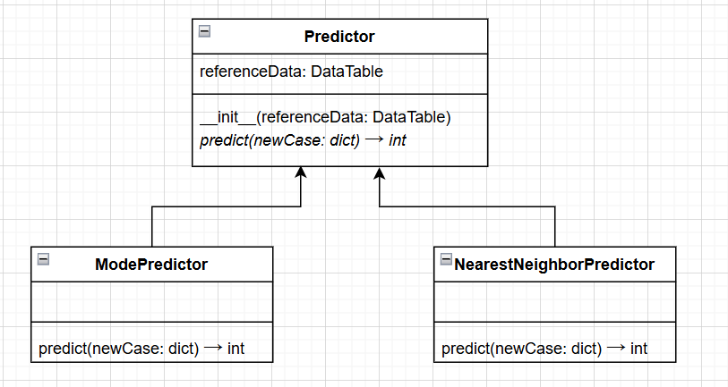

Task 3) A custom exception (exceptions.py)
Create a custom Exception class called OutOfSampleError. Making custom exception classes is easy: you just need to define your class as a subclass of Exception, and that’s it! See exceptions.py in Lab1 for examples.
An “out-of-sample prediction” is an inference or generalization made from historical data, about a new situation that is very different from the historical situations. Making predictions about situations similar to our past experience is already kind of risky - making predictions about unprecedented situations should not be attempted. Your program should raise OutOfSampleError if one of the new patients is too different from the patients in the historical data.
For this assignment, a patient is considered “too different” if any of their feature values is less than the min or greater than the max for that feature in the historical data.

Example
Suppose in the historical data:
● Feature4 ranges from 0.1 to 0.9
If a new case has Feature4 = 1.0, then raise OutOfSampleError
A meaningful error message should be displayed in the terminal. Eg:
OutOfSampleError: Feature4 with value 1.0 is outside historical range [0.1, 0.9]

Important: Missing values represented by ? must be handled according to the missing-value policy in Task 1. Do not raise OutOfSampleError for missing values. This exception is reserved for new patients whose valid feature values fall outside the historical minimum and maximum ranges.
When a missing value is replaced with the historical feature mean, use the resulting numeric value when checking the feature range. Since the mean is calculated from valid historical values, it should fall within the historical range when valid values exist.

Task 4) Write the main program
In main.py, load the historical and new_cases datasets (as DataTable objects), and make predictions for each new case using each of the 2 prediction methods.
Then compute the accuracy of the two sets of predictions by comparing them to the true outcomes in cancer_new_cases_labels.

Code requirements
- No external libraries (no pandas, numpy, scikit-learn, etc.)
- Allowed: math.sqrt and your own modules.
- Use the 9 features only for distances (never the label).
- Use OOP: keep logic in classes/methods; keep main.py small.
- Implement and enforce OutOfSampleError exactly as specified.
- After completing and testing your solution, create a Jupyter Notebook demonstrating how your program satisfies the assignment requirements and grading rubric. Keep the notebook, source files, supporting files, and input data in the same project folder so the notebook runs without modification.
- The notebook should:
  - Import your code or required modules.
  - Load any required data or files.
  - Include normal, special, and error test cases (where applicable).
  - Required Test Cases
For each test, show the input, expected behavior, and actual result.
Test | Expected Behavior
1. Load CSV | Load valid numeric data and convert values to floats.
2. DataTable methods | Verify all required methods return correct results.
3. Missing historical values | Replace ? with the mean of valid values in the same historical feature column.
4. Missing new-case values | Replace ? with the corresponding historical feature mean.
5. Multiple missing values | Replace all missing values without removing or reordering rows.
6. Majority-class prediction | Predict the most common historical tumor type.
7. Nearest-neighbor prediction | Predict using the closest historical patient based on the nine features only.
8. Out-of-range feature | Raise OutOfSampleError with a meaningful message.
9. Multiple out-of-range features | Raise OutOfSampleError for the first out-of-range feature detected.
10. Accuracy calculation | Calculate both predictors' accuracy against the 100 corresponding labels.

Additional Requirements
- Use small test datasets where needed to verify expected results.
- Confirm that missing-value replacement preserves row count and order.
- Confirm that missing values alone do not raise OutOfSampleError.
- Catch expected exceptions so that subsequent notebook tests can run.
- Demonstrate both predictors and their accuracy in the notebook.
  - For each test case, show the input, expected behavior, and actual result.
  - Demonstrate that your program correctly detects and handles errors where appropriate.

- Git expectations:
  - Multiple small commits showing progress.
  - At least one feature branch and a merge via Pull Request.
  - A single “big dump” at the deadline = 0 for the Git category.

Starter code
- data_representation.py - write the DataTable class in this file
- predictors.py - write the MajorityClassPredictor, and NearestNeighborPredictor classes in this file
- exceptions.py - write the OutOfSampleError class in this file
- main.py - write your main program in this file. Note that most of the logic for this assignment will be encapsulated in your classes, making your main program quite short.

Hints
This is a large program, so take advantage of the modularity that classes provide: tackle the coding one class, one method at a time, testing as you go. Then use those classes to build your main program.
Write the DataTable class first, then the Predictor abstract class, then the others.

Grading
Item | Points
Classes written and used appropriately | 8
Functionality (requirements met) | 9
Jupyter Notebook (organization, testing, and demonstration of requirements) | 5
Code style and readability | 2
Git commit history | 3
Total | 27

Submission
Submit your work to the designated D2L submission folder as a single ZIP file containing:
- All source files (.py).
- Your Jupyter Notebook (.ipynb).
- The required input data and any supporting files needed to run your notebook and program.
- Screenshot(s) of your complete GitHub commit history (for you and your partner, if applicable), along with confirmation that your work has been pushed to GitHub.

